PC functional simulation

PC has 4 different source:

1. Continuously increasing: nextPC = PC + 4
2. Branch instruction: nextPC = PC + 4 + offset*4
3. Jump instruction: nextPC = (PC+4)[31:28] & addr & “00”
4. Halt instruction: nextPC = PC

For each situation, I tested the PC unit on 1000 random cases and used ‘assert’ statement to check the output automatically (see tb_pc.vhd for details). The stage signal would change to FINISH only when all test cases passed, otherwise, the simulation would stop with severity level ‘failure’.

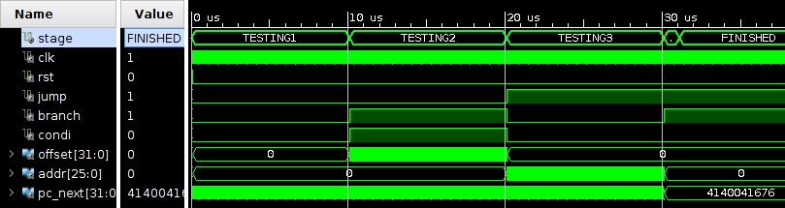

▲ Signal wave overview. All cases passed.

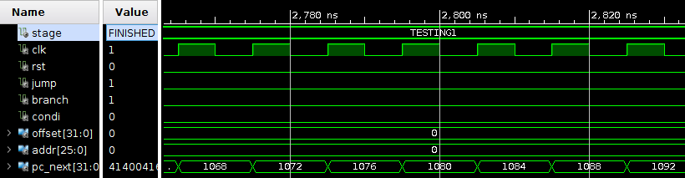

▲ Testing continuously increasing

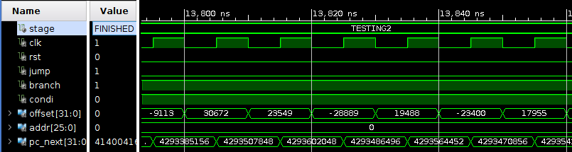

▲ Testing branch instruction

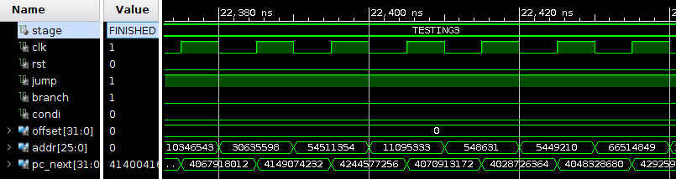

▲ Testing jump instruction

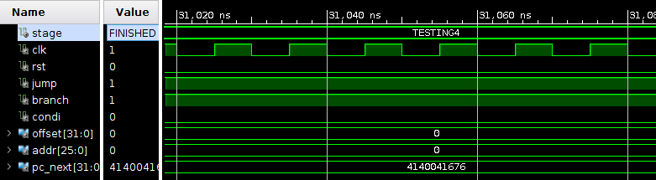

▲ Testing halt instruction